# ECE 162 Week 6 -- DAQ

Name: Brian Loughran ([btl217@lehigh.edu](mailto:btl217@lehigh.edu))

## Purpose

In this lab we will be generating alternating signals and capturing them on the computer with the aid of a data acquisition unit

## Theory

With the use of the data acquisition unit we are able to display electrical signals graphically on the computer. This is done with the aid of LabVIEW by creating a block diagram in the virtual instrument (VI). Using the signal generator, we are able to output several different types of electrical waves. For this lab we are creating sinusoidal waves, saw tooth waves, and a square wave.

There are some characteristics of the waves which we were supposed to calculate upon collection of the waves. Below, in figure 1, is a sinusoidal wave, and labeled on this diagram is the amplitude and period. These two characteristics of the wave are crucial in calculating many other components.

Figure 1

Using the period, it is simple to calculate the frequency of the sin wave. The period is denoted by the symbol τ, and is measured in seconds. The frequency is denoted by the symbol f, and is measured in Hertz (Hz). The equation relating these two is as follows:

$$τ=\frac{1}{f} (eq. 1)$$

Another important concept in studying waves is angular frequency, which uses the variable ω, and is measured in units of (1/s). The equation for finding the angular frequency is shown below:

$$ω=2πf=\frac{2π}{τ} (eq.2)$$

For a sinusoidal wave, one interesting aspect is the RMS (root mean squared) value of the wave. This is a comparison between DC and alternating current, and is a measure of relative amplitudes to get the same power for a circuit using the same resistor. For sinusoidal waves, the RMS value is simple to calculate, and is given by the following equation (equation 3):

$$V_{RMS}= \sqrt{2} I (eq.3)$$

There are also several interesting values which can be calculated for the square waveform. The first is the pulse repetition rate. This is the number of times per second a pulse is generated. This is a frequency measurement, and is therefore measured in Hz.

Another interesting measure for square waveforms (pulses) is the duty cycle. This is the ratio of the pulse “on time” to the pulse repetition time. This is shown in the diagram below (figure 2):

Figure 2

One last interesting value to calculate for square waves is the mark to space ratio. For our purposes, the pulse is either considered to be positive or negative at all times. The mark to space ratio is a ratio which measures the time for which the pulse is positive, and compares it to when it is negative. This may seem similar to the duty cycle, but let me explain a key difference. For the duty cycle, as the value of the pulse “on time“ approaches the pulse repetition time, the value approaches 1. For the mark to space ratio, as the value of the pulse “on time”( or the time for which the pulse is positive) the value approaches infinity. This is because for the mark to space ratio, the denominator (also the time which the pulse is negative) approaches 0 as the “on time” approaches the pulse repetition time.

## Experimental Method

* Wire the DAQ to the breadboard, specifically to the signal generation ports
* Create LabVIEW VI
* Generate a sinusoidal wave, and record the readings from the computer
* Generate a saw tooth wave. Record the readings from the computer
* Generate a square waveform. Record the readings from the computer

## Diagram

Below (Figure 3) is a diagram of the LabVIEW VI which we used for this lab. While this VI is quite simple (just data acquisition and display), they can get far more complicated as you increase functionality and computation, which makes LabVIEW an incredibly versatile tool for signal processing.

Figure 3

The following diagram (Figure 4) is a circuit diagram that we used for this lab. It includes the DAQ, and the signal generator. The signal generator is denoted as a dependant voltage source, because it can switch from different types of waveforms, amplitudes, and frequencies.

Figure 4

## Results

The first plow which was found was the sinusoidal wave. For all plots we were to find period, frequency, amplitude, sampling rate, and sampling interval. On top of this, for the sin wave, we were also asked to find the RMS value of the waveform. A table containing all requested information is shown below (Table 1), and a graphical representation from LabVIEW is included below that (Figure 5).

|  |  |  |  |  |  |
| --- | --- | --- | --- | --- | --- |
| Τ (s) | f (Hz) | Amplitude (V) | Sampling Rate (Hz) | Sampling Interval (s) | RMS Value (V) |
| .026 | 35.71 | 10.5 | 5000 | .0002 | 7.42 |

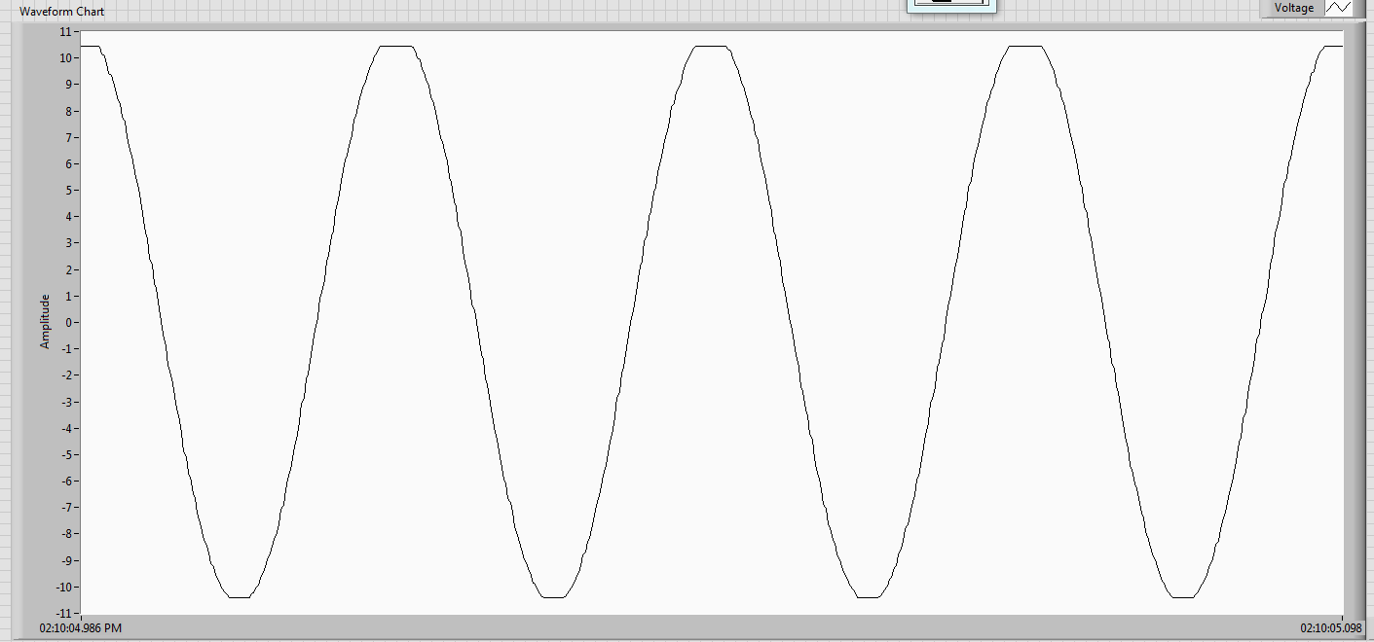

Figure 5

The next waveform which we were asked to analyze was a saw tooth waveform. This had no extra quantities to calculate, therefore all that was asked was the period, frequency, amplitude, sampling rate, and sampling interval. A table containing all relevant information is included below (Table 2), and below that is a plot of the waveform (Figure 6).

|  |  |  |  |  |
| --- | --- | --- | --- | --- |
| Τ (s) | f (Hz) | Amplitude (V) | Sampling Rate (Hz) | Sampling Interval (s) |
| .028 | 36.04 | 10.5 | 5000 | .0002 |

Table 2

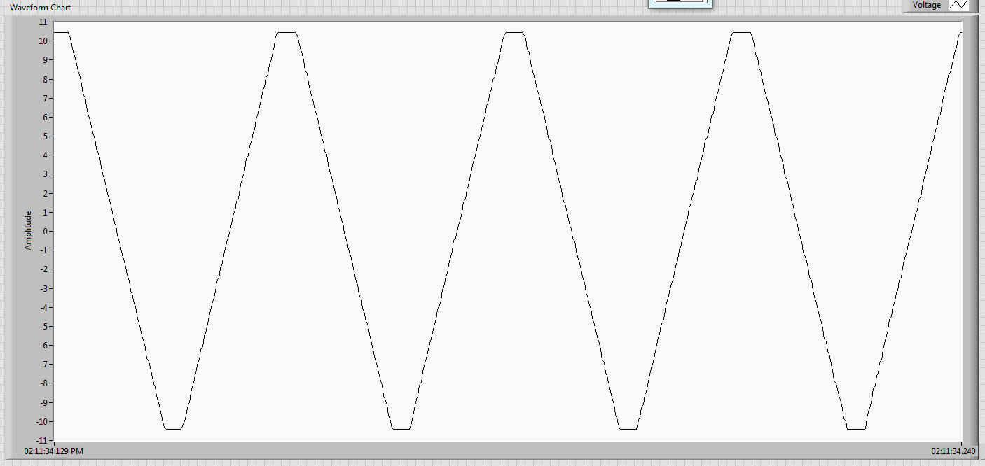

Figure 6

Moving on to the last of the waveforms measured, the final waveform is a square waveform, or pulse. For this waveform, we were asked to not only measure period, frequency, amplitude, sampling rate and sampling interval, but were also asked to calculate the pulse repetition rate, the duty cycle, and the mark-to-space ratio. This is all included in the table below (Table 3). As you may have already guessed, the plot for this waveform is below the table (Figure 7)

|  |  |  |  |  |  |  |  |
| --- | --- | --- | --- | --- | --- | --- | --- |
| Τ (s) | f (Hz) | Amplitude (V) | Sampling Rate (Hz) | Sampling Interval (s) | Pulse Repetition (Hz) | Duty Cycle | Mark-to-Space |
| .034 | 29.85 | 10.5 | 5000 | .0002 | 29.85 | .46 | .85 |

Table 3

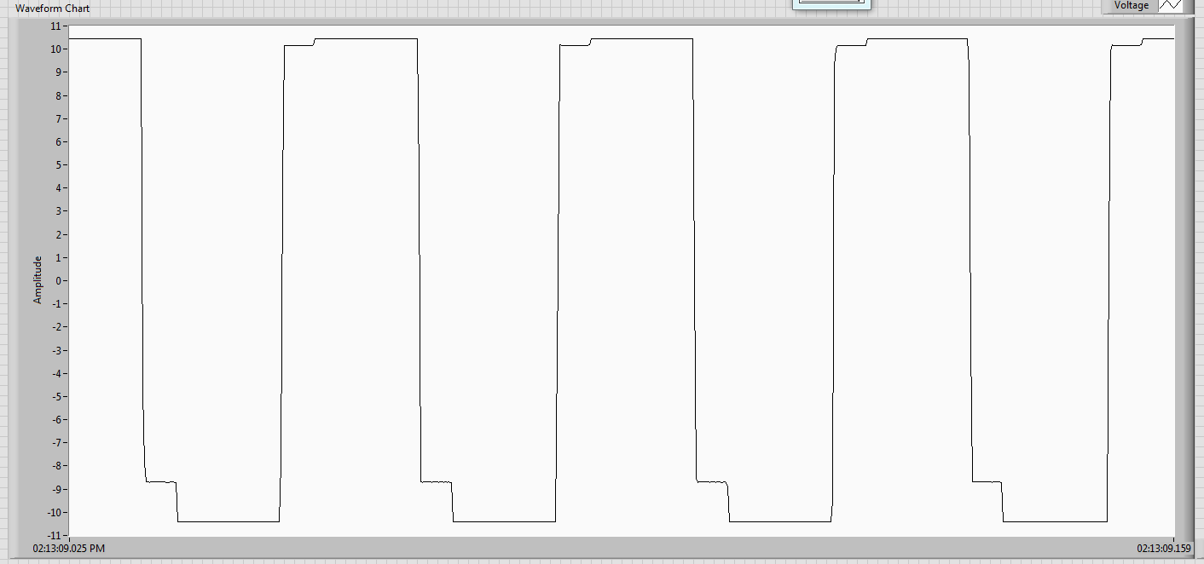

Figure 7

## Discussion

This lab was far less computational than the previous couple labs, which was nice. The issue is that this makes less material for the discussion part of the lab, which in turn makes writing the discussion part of the lab more difficult. The only error that could be associated with this lab is error in the appearance of the waveforms in comparison with their ideal function.

Because of the high sampling rate, there are plenty of points per period, which produces relatively smooth curves. If you start to approach a sampling rate which is 20 times or less the frequency of the waveform you will start to see some choppiness in the data acquisition. It is recommended that you always sample at over 20 times the period which you are sampling to attain smooth plots.

Both the sinusoidal and saw tooth waveforms are relatively good. There are minor imperfections in the square waveform. If you compare Figure 7 (real world case), with Figure 2 (ideal case), you can see that there are small “steps” near the transition from positive to negative. This is to be expected, the voltmeter was working at very high frequency, and changing voltage instantaneously is impossible in our lab conditions. For all intents and purposes, those small “steps” can be ignored.

## Conclusion

This lab was interesting to do because it produced such a clear picture of what was actually going on. Using the Data Acquisition Unit, we are able to clearly see the way that signal generators output. This was done by creating a VI in LabVIEW to take in signals from the DAQ and process those signals into a plot which could be formatted to our needs. This gave great data on different waveforms, and the plots that were created were very close to the idea case, with nothing more than minor imperfections.